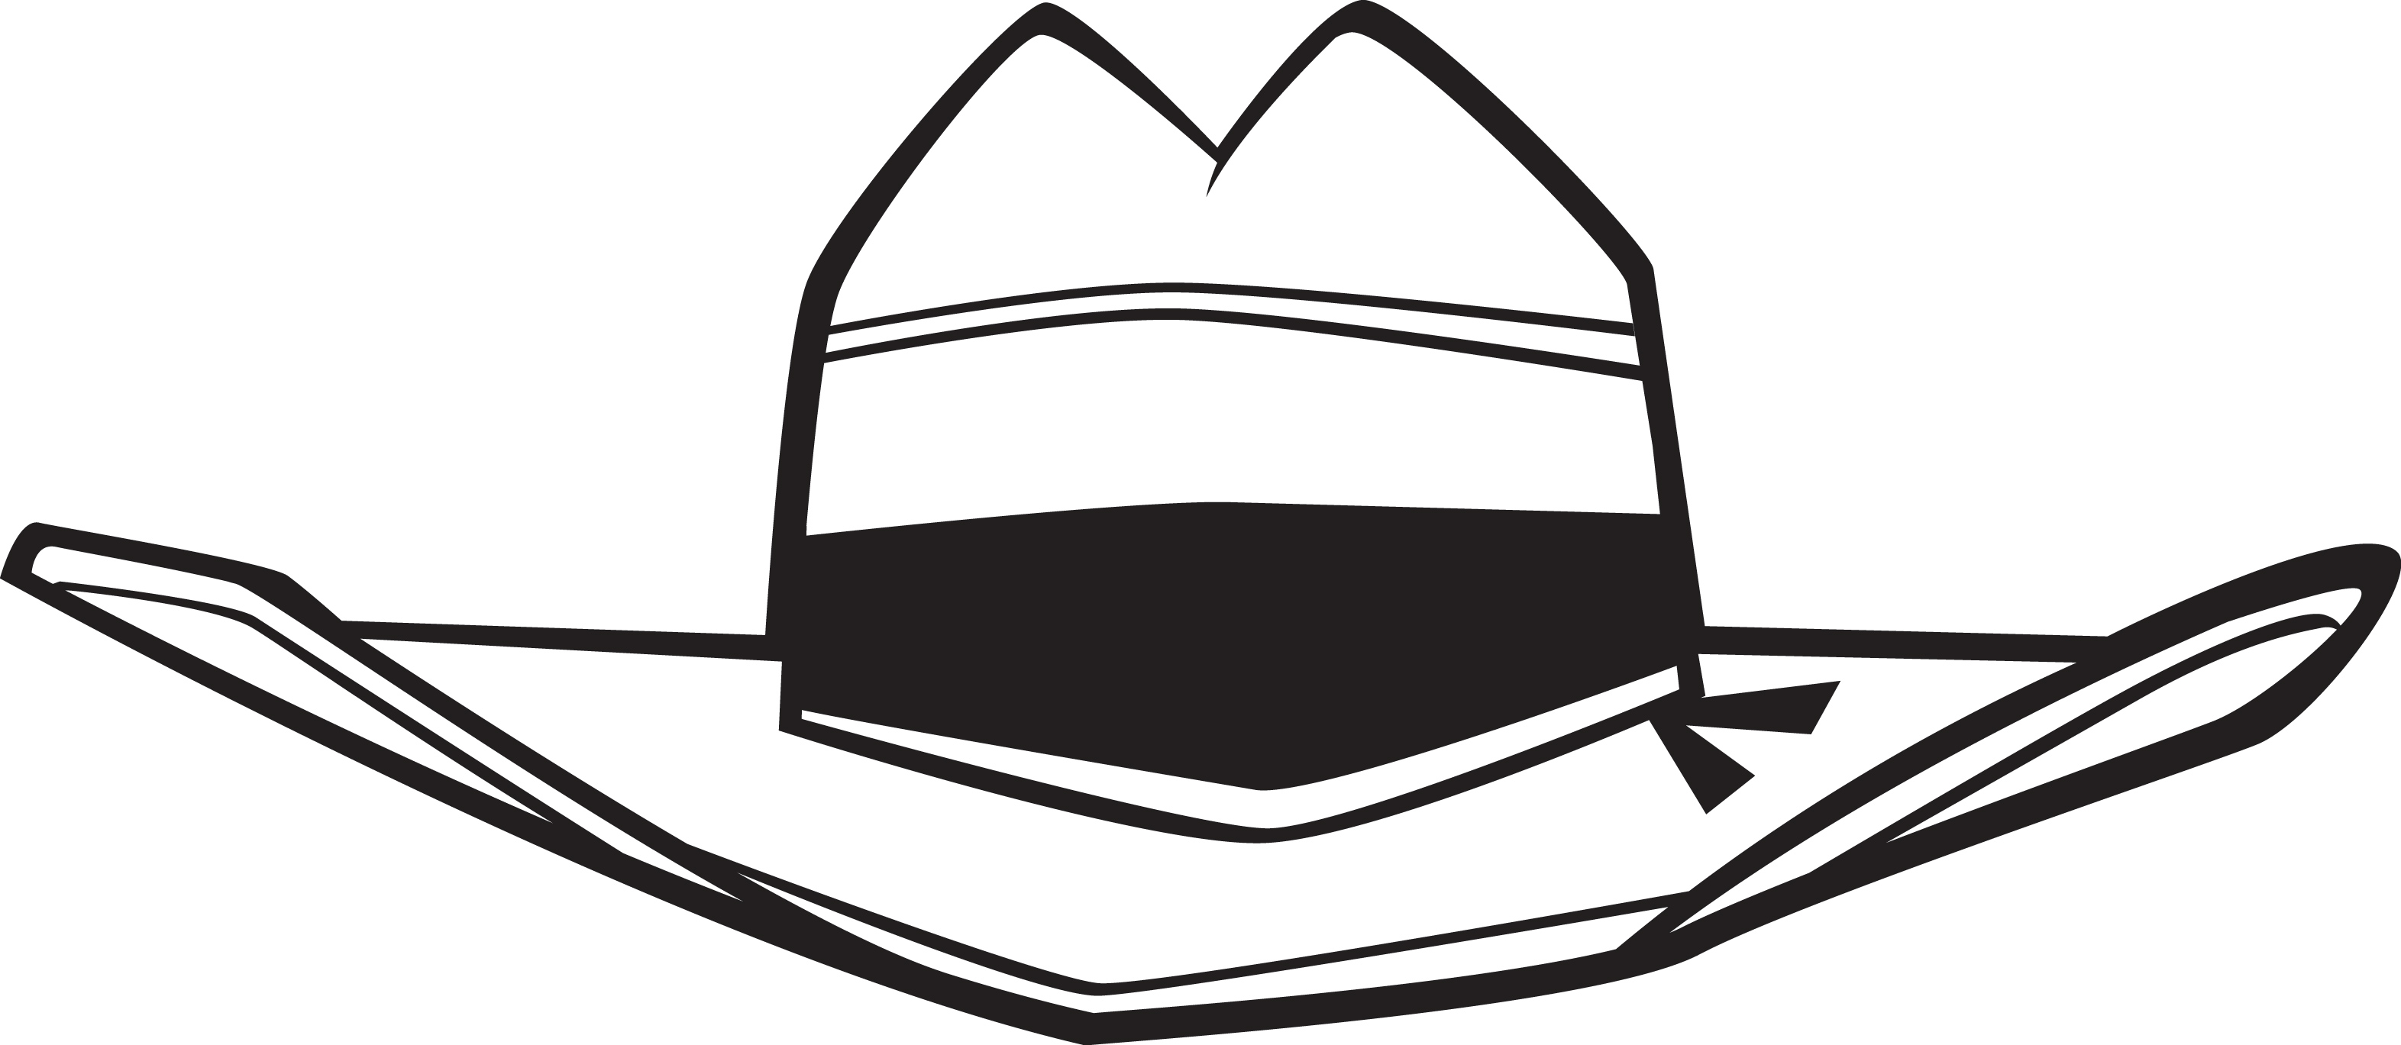
Hats Off
To You!
Hats Off
To You!

